🫀 Heart Disease Prediction Data Analysis Report

1. Introduction
This project applies data science techniques to patient health records to predict the likelihood of heart disease. By analyzing clinical features such as age, cholesterol, blood pressure, and exercise response, the study demonstrates how statistical methods and machine learning can support preventive healthcare and decision-making.
2. Dataset Overview
- Source: Heart Disease Prediction dataset
- Attributes: Age, Sex, Chest Pain Type, Blood Pressure, Cholesterol, Fasting Blood Sugar, EKG Results, Max Heart Rate, Exercise Angina, ST Depression, Slope of ST, Number of Vessels, Thallium Test
- Target Variable: Heart Disease (Presence/Absence)
- Size: 300+ patient records with mixed categorical and numerical features
3. Objectives
- Explore demographic and clinical factors influencing heart disease.
- Detect outliers in cholesterol and blood pressure.
- Visualize relationships between key variables (e.g., age vs. disease presence).
- Build predictive models to classify patients into “Presence” or “Absence.”
- Perform hypothesis testing to evaluate differences in risk factors.
4. Tools & Libraries
- Python – core programming language
- Pandas & NumPy – data cleaning and manipulation
- Matplotlib & Seaborn – visualization
- Scikit-learn – machine learning models
- Jupyter Notebook – documentation and reproducibility
5. Key Analyses
Exploratory Data Analysis (EDA)
- Age distribution shows higher prevalence in older patients.
- Cholesterol and blood pressure levels vary widely, with some extreme outliers.
- Gender-based differences observed in disease occurrence.
- Correlation heatmap highlights strong predictors such as chest pain type and exercise angina.
Outlier Detection
- IQR and Z-score methods applied to cholesterol and blood pressure.
- Extreme values flagged for medical review.
Visualizations (placeholders for figures)
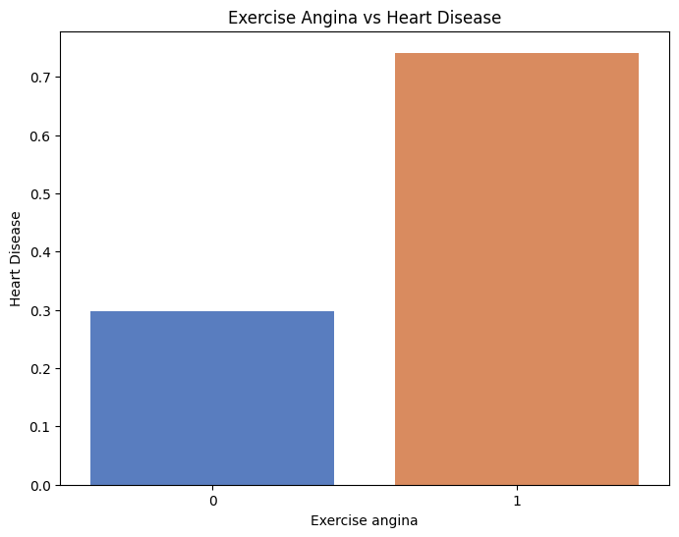
- Bar Chart: Heart disease prevalence by chest pain type.

Correlation Matrix : table that shows the correlation coefficients between multiple variables in a dataset.
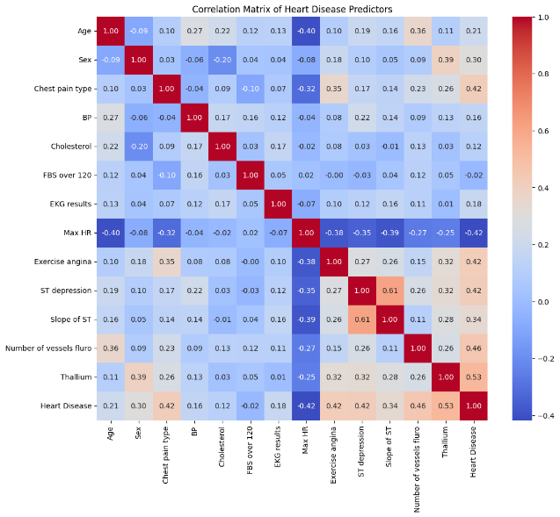

Histogram : Age Distribution shows how patient ages are spread across the dataset.
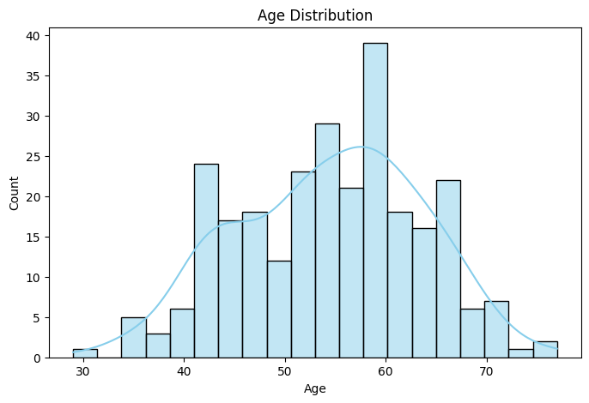

Bar chart :Chest Pain Type vs Heart Disease compares the frequency of different chest pain categories with the presence or absence of heart disease.
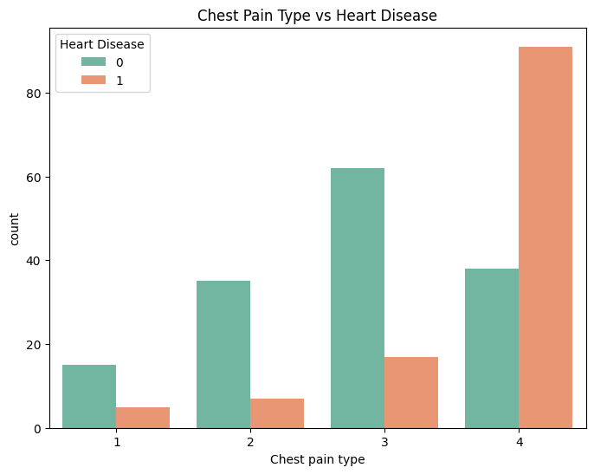

6. Insights
- Older patients and those with high cholesterol/blood pressure are at greater risk.
- Chest pain type and exercise-induced angina are strong predictors.
- Logistic regression provides interpretable coefficients, while Random Forest improves predictive performance.
- Outlier detection highlights extreme cholesterol values that may require medical attention.
7. Conclusion
This project demonstrates how patient health data can be leveraged to predict heart disease risk. Combining statistical methods, visualization, and machine learning provides actionable insights for clinicians and researchers. The predictive model serves as a decision-support tool, while the findings highlight key risk factors for targeted interventions.

